Contents
2. Process and Process Scheduling 1
2.1 Introduction to Process and Program 1
2.2 Introduction Process Life Cycle 3
2.3 Process Control Block 5
Structure of the Process Control Block 5
2.4 Process State 6
1.4 Introduction to Process Scheduling 7
1.4.1 Process Scheduling Queues 8

2. Process and Process Scheduling

2.1 Introduction to Process and Program
Process
A process is basically a program in execution. The execution of a process must progress in a sequential fashion.
A process is defined as an entity which represents the basic unit of work to be implemented in the system.
To put it in simple terms, we write our computer programs in a text file and when we execute this program, it becomes a process which performs all the tasks mentioned in the program.
When a program is loaded into the memory and it becomes a process, it can be divided into four sections ─ stack, heap, text, and data. The following image shows a simplified layout of a process inside main memory −
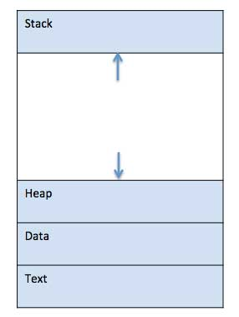
Stack
The process Stack contains the temporary data such as method/function parameters, return address and local variables.
Heap
This is dynamically allocated memory to a process during its run time.
Text
This includes the current activity represented by the value of Program Counter and the contents of the processor's registers.
Data
This section contains the global and static variables.

Program
A program is a piece of code which may be a single line or millions of lines. A computer program is usually written by a computer programmer in a programming language. For example, here is a simple program written in C programming language −
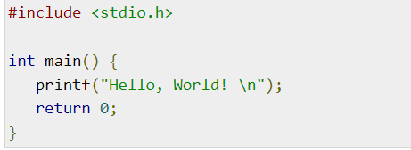

A computer program is a collection of instructions that performs a specific task when executed by a computer. When we compare a program with a process, we can conclude that a process is a dynamic instance of a computer program.
A part of a computer program that performs a well-defined task is known as an algorithm. A collection of computer programs, libraries and related data are referred to as a software.
Execution of the program starts via GUI mouse clicks, command line entry of its name, etc. A program is a passive entity as it resides in the secondary memory, such as the contents of a file stored on disk. One program can have several processes.
S.N. | Program | Process
1. | Program contains a set of instructions designed to complete a specific task. | Process is an instance of an executing program.
2. | Program is a passive entity as it resides in the secondary memory. | Process is a active entity as it is created during execution and loaded into the main memory.
3. | Program exists at a single place and continues to exist until it is deleted. | Process exists for a limited span of time as it gets terminated after the completion of task.
4. | Program is a static entity. | Process is a dynamic entity.
5. | Program does not have any control block. | Process has its own control block called Process Control Block.

2.2 Introduction Process Life Cycle
When a process executes, it passes through different states. These stages may differ in different operating systems, and the names of these states are also not standardized. A process changes its state during its execution which is called the process life cycle.
In general, a process can have one of the following five states at a time.
S.N. | State & Description
1 | Start  This is the initial state when a process is first started/created.
2 | Ready  The process is waiting to be assigned to a processor. Ready processes are waiting to have the processor allocated to them by the operating system so that they can run. Process may come into this state after Start state or while running it by but interrupted by the scheduler to assign CPU to some other process.
3 | Running  Once the process has been assigned to a processor by the OS scheduler, the process state is set to running and the processor executes its instructions.
4 | Waiting  Process moves into the waiting state if it needs to wait for a resource, such as waiting for user input, or waiting for a file to become available.
5 | Terminated or Exit  Once the process finishes its execution, or it is terminated by the operating system, it is moved to the terminated state where it waits to be removed from main memory.
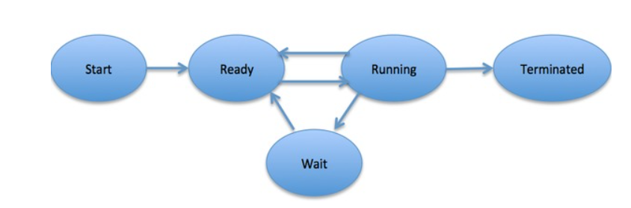

2.3 Process Control Block
A Process Control Block is a data structure maintained by the Operating System for every process. Each process is represented in operating system by Process Control Block (PCB) also called a task control block. The PCB is identified by an integer process ID (PID).

Structure of the Process Control Block
The process control stores many data items that are needed for efficient process management. Some of these data items are explained with the help of the given diagram.
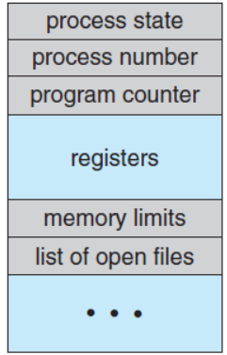
Pointer –
It is a stack pointer which is required to be saved when the process is switched from one state to another to retain the current position of the process.
Process state –
It stores the respective state of the process.
Process number –
Every process is assigned with a unique id known as process ID or PID which stores the process identifier.
Program counter –
It stores the counter which contains the address of the next instruction that is to be executed for the process.
Register –
These are the CPU registers which includes: accumulator, base, registers and general-purpose registers.
Memory limits –
This field contains the information about memory management system used by operating system. This may include the page tables, segment tables etc.
Open files list –
This information includes the list of files opened for a process.

2.4 Process State
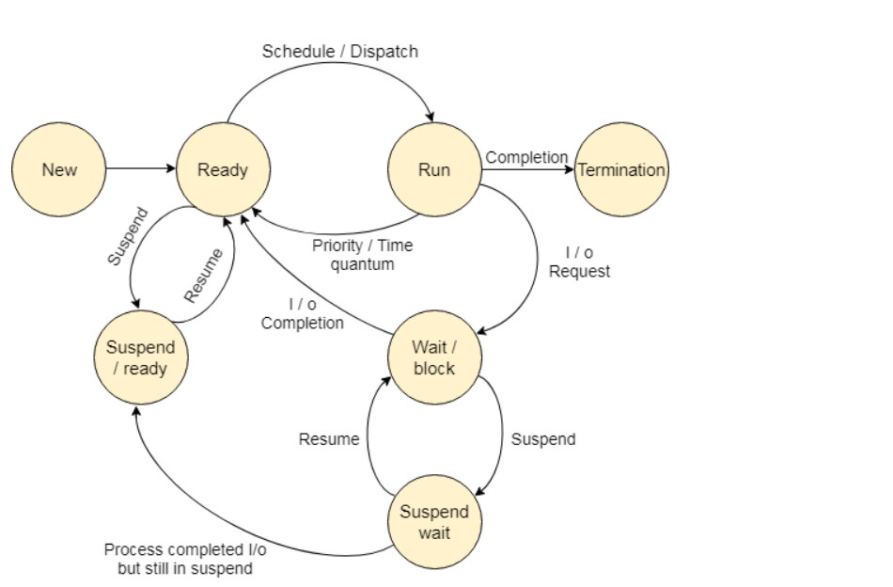
Fig: State Diagram
The process, from its creation to completion, passes through various states. The minimum number of states is five.
The names of the states are not standardized although the process may be in one of the following states during execution.
New (Create):
In this step, the process is about to be created but not yet created, it is the program which is present in secondary memory that will be picked up by OS to create the process.

Ready
New -> Ready to run. After the creation of a process, the process enters the ready state i.e. the process is loaded into the main memory. The process here is ready to run and is waiting to get the CPU time for its execution. Processes that are ready for execution by the CPU are maintained in a queue for ready processes.
Running
One of the processes from the ready state will be chosen by the OS depending upon the scheduling algorithm. Hence, if we have only one CPU in our system, the number of running processes for a particular time will always be one. If we have n processors in the system, then we can have n processes running simultaneously.
Blocked or wait
From the Running state, a process can make the transition to the block or wait state depending upon the scheduling algorithm or the intrinsic behavior of the process.
When a process waits for a certain resource to be assigned or for the input from the user then the OS move this process to the block or wait state and assigns the CPU to the other processes.
Terminated or completed
Process is killed as well as PCB is deleted.
Suspend ready
Process that was initially in the ready state but were swapped out of main memory (refer Virtual Memory topic) and placed onto external storage by scheduler are said to be in suspend ready state. The process will transition back to ready state whenever the process is again brought onto the main memory.

2.5 Introduction to Process Scheduling

The process scheduling is the activity of the process manager that handles the removal of the running process from the CPU and the selection of another process based on a particular strategy.
Process scheduling allows OS to allocate a time interval of CPU execution for each process. Another important reason for using a process scheduling system is that it keeps the CPU busy all the time. This allows you to get the minimum response time for programs.

2.6 Process Scheduling Queues
The OS maintains all PCBs in Process Scheduling Queues. The OS maintains a separate queue for each of the process states and PCBs of all processes in the same execution state are placed in the same queue. When the state of a process is changed, its PCB is unlinked from its current queue and moved to its new state queue.
There are the following queues maintained by the Operating system.
1. Job Queue
In starting, all the processes get stored in the job queue. It is maintained in the secondary memory. The long term scheduler (Job scheduler) picks some of the jobs and put them in the primary memory.
2. Ready Queue
Ready queue is maintained in primary memory. The short term scheduler picks the job from the ready queue and dispatch to the CPU for the execution.
3. Waiting Queue
When the process needs some IO operation in order to complete its execution, OS changes the state of the process from running to waiting. The context (PCB) associated with the process gets stored on the waiting queue which will be used by the Processor when the process finishes the IO.
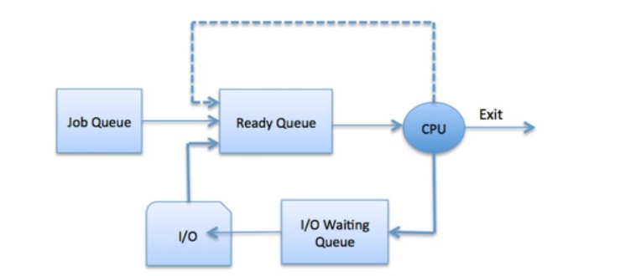

2.7 Types of Process Schedulers
Schedulers are special system software which handle process scheduling in various ways. Their main task is to select the jobs to be submitted into the system and to decide which process to run. Schedulers are of three types –
- Long-Term Scheduler
- Short-Term Scheduler
- Medium-Term Scheduler

2.7.1 Long-Term Scheduler
It is also called a job scheduler. A long-term scheduler determines which programs are admitted to the system for processing. It selects processes from the queue and loads them into memory for execution. Process loads into the memory for CPU scheduling.
The primary objective of the job scheduler is to provide a balanced mix of jobs, such as I/O bound, and processor bound. It also controls the degree of multiprogramming.
When a process changes the state from new to ready, then there is use of long-term scheduler.

2.7.2 Short-Term Scheduler
It is also called as CPU scheduler. Its main objective is to increase system performance in accordance with the chosen set of criteria. It is the change of ready state to running state of the process. CPU scheduler selects a process among the processes that are ready to execute and allocates CPU to one of them.
Short-term schedulers, also known as dispatchers, make the decision of which process to execute next. Short-term schedulers are faster than long-term schedulers.

2.7.3 Medium-Term Scheduler
Medium-term scheduling is a part of swapping. It removes the processes from the memory. It reduces the degree of multiprogramming. The medium-term scheduler is in-charge of handling the swapped out-processes.
A running process may become suspended if it makes an I/O request. A suspended processes cannot make any progress towards completion. In this condition, to remove the process from memory and make space for other processes, the suspended process is moved to the secondary storage. This process is called swapping, and the process is said to be swapped out or rolled out. Swapping may be necessary to improve the process mix.

2.8 Concept of Preemptive and Non-preemptive Scheduling
Preemptive Scheduling is a CPU scheduling technique that works by dividing time slots of CPU to a given process. The time slot given might be able to complete the whole process or might not be able to it. When the burst time of the process is greater than CPU cycle, it is placed back into the ready queue and will execute in the next chance. This scheduling is used when the process switch to ready state.
Algorithms that are backed by preemptive Scheduling are round robin (RR), priority, SRTF (shortest remaining time first).
Non-preemptive Scheduling is a CPU scheduling technique the process takes the resource (CPU time) and holds it till the process gets terminated or is pushed to the waiting state. No process is interrupted until it is completed, and after that processor switches to another process.
Algorithms that are based on non-preemptive Scheduling are non-preemptive priority, and shortest Job first.
Preemptive Scheduling | Non-Preemptive Scheduling
Resources are allocated according to the cycles for a limited time. | Resources are used and then held by the process until it gets terminated.
The process can be interrupted, even before the completion. | The process is not interrupted until its life cycle is complete.
Starvation may be caused, due to the insertion of priority process in the queue. | Starvation can occur when a process with large burst time occupies the system.
Maintaining queue and remaining time needs storage overhead. | No such overheads are required.
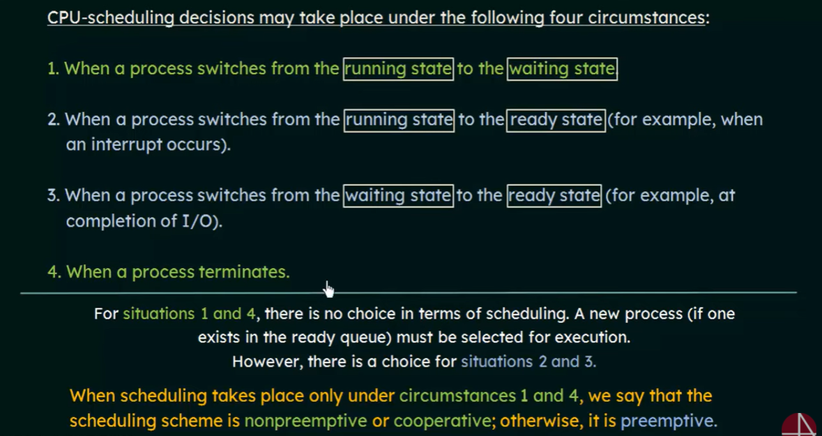

2.9 Concept of thread and its life cycle
A process is divided into several light-weight processes, each light-weight process is said to be a thread. A thread is a path of execution within a process. A process can contain multiple threads. The thread has a program counter that keeps the tracks of which instruction to execute next, if process registers, which hold its current working variables. It has a stack which contains the executing thread history. The life cycle of thread is Born state, Ready state, Running state, Blocked State, Sleep, Dead.
The process can be split down into so many threads. For example, in a browser, many tabs can be viewed as threads. MS Word uses many threads - formatting text from one thread, processing input from another thread, etc.
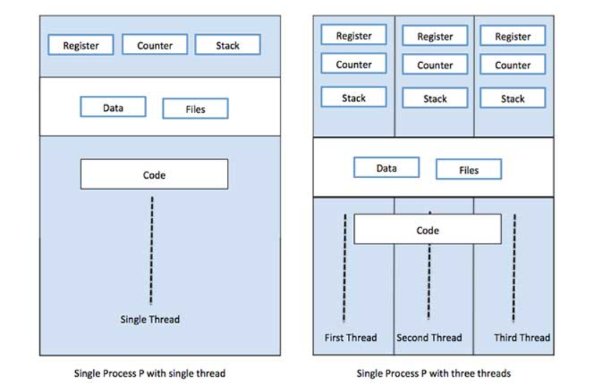

Differences between process and thread
S.N. | Process | Thread
1 | Process is heavy weight or resource intensive. | Thread is light weight, taking lesser resources than a process.
2 | Process switching needs interaction with operating system. | Thread switching does not need to interact with operating system.
3 | In multiple processing environments, each process executes the same code but has its own memory and file resources. | All threads can share same set of open files, child processes.
4 | Blocking process will not block another process. | Blocking thread will block entire process.
5 | Multiple processes without using threads use more resources. | Multiple threaded processes use fewer resources.
6 | In multiple processes each process operates independently of the others. | One thread can read, write or change another thread's data.

